PENETRATION TESTING REPORT
FOOTPRINTING & NETWORK SCANNING PHASES
W2-PM-FINAL | CYBERSECURITY | NETWORKWALKS

Pentester Name  (Cybersecurity Professional) | Rodgers Moonde
Program/Batch | B083-Networkwalks
Date | 18 September 2026
Modules completed | W2-PM1 (Multiple Kali Tools)  W2-PM5 (Zenmap Scanning)
Client/Target | 1. Networkwalks (secured written permission already)  2. My own local LAN Network
Permission secured from client? | Yes
Phases covered | Phase 1: Reconnaissance & Footprinting  Phase 2: Scanning & Network Discovery  Phase 3-5: In Progress

1. Liability Disclaimer
I have performed these activities only on the systems & devices where I had secured written permission or the devices/systems that I own myself. All these materials are for education and research purpose only. Do not use anything from here to break the law. The instructor, the authors and Networkwalks are not responsible for what you do with this knowledge. Every action you take is your own responsibility. Misuse can lead to criminal charges, heavy fines, loss of your job and a permanent record. In most countries unauthorised access is a crime even when nothing is damaged.

2. Introduction
This report covers Week 2 footprinting for the NetworkWalks Cybersecurity Internship B083. It combines two modules:
- W2-PM1 - Project Module 1 - Footprinting with Multiple Tools v1: Using Kali Linux tools to gather public information about networkwalks.com
- W2-PM2 - Project Module 2 - Footprinting with GHDB v1: Using Google Hacking Database (GHDB) / Google Dorks to identify sensitive information exposure.
Both modules are part of Phase 1 - Reconnaissance. The goal is to demonstrate how an attacker collects OSINT before any scanning/exploitation. All commands were executed in Kali Linux VM. Target for PM1: networkwalks.com (authorized scope). Target for PM2: GHDB dorks executed via Google search with site: networkwalks.com filter where applicable to stay in scope.
Every step includes command, observed result, evidence location, and attacker perspective.

3. Tools Used
The table below lists each tool used in this report and its purpose.
Tool / Technique | Purpose in Footprinting
Kali Linux & Windows | Operating systems used for reconnaissance activities
WHOIS | Domain registration, registrar, creation/expiry dates, name servers
whatweb | Fingerprint CMS, plugins, server, IP, cookies
nslookup / dig | Resolve domain to IP, query DNS records
Curl -I / -v | Inspect HTTP headers, banner, REST API endpoints
wafw00f | Detect Web Application Firewall
DNSRecon / DNSEnum | Enumerate NS, MX, TXT, SPF, SRV records
theHarvester | Collect emails, subdomains from public sources
Google Dorks / GHDB | Find exposed files, directories, login pages, error messages using advanced Google search operators
Zenmap (Nmap GUI) | Scan the local subnet to find live hosts, IPs and MAC addresses.
Windows CMD | Local IP and MAC address identification

4. Activities Performed

4.1 PM1 - Footprinting with Multiple Tools
1. WHOIS - whois networkwalks.com - Obtained registrar, creation date, name servers. Evidence: evidence/week-02/PM1-MULTI-TOOLS/whois.png
2. WhatWeb - whatweb -v networkwalks.com - Identified WordPress 7.0.4, WP Download Manager 3.3.58, server info. Evidence: whatweb.png
3. Nslookup - nslookup networkwalks.com - Resolved to 192.232.216.135. Validated with dig networkwalks.com
4. Curl - curl -I https://networkwalks.com - Revealed HTTP/2 200, server headers, X-Powered-By, exposed /wp-json/ endpoint
5. Wafw00f - wafw00f https://networkwalks.com - Detected ModSecurity (SpiderLabs) WAF
6. DNSRecon - dnsrecon -d networkwalks.com -t std - Enumerated NS, MX, TXT (SPF), A records
7. theHarvester - theHarvester -d networkwalks.com -b google - Limited to authorized domain to gather emails/subdomains

4.2 Network Scanning with Zenmap
For the second activity, I used Zenmap to perform network discovery on my local network. The practical required me to identify my local IP address and subnet, discover live hosts, identify their IP and MAC addresses, and generate a network topology.
I first used the Windows ipconfig command to identify my local IP address and LAN subnet. I then entered the subnet into Zenmap and selected Ping Scan to identify active hosts.
The scan identified two (2) live hosts together with their MAC Addresses:
- 10.82.33.253 MAC Address: 76:79:B3:C1:0A:73
- 10.82.33.134 MAC Address: None detected
After completing the scan, I opened the Topology section in Zenmap, enabled the legend and saved the network topology in PDF format as required by the practical task.

5. Risk Analysis / Impact
Based on the information collected during the footprinting and network scanning activities, I identified the following potential risks.
# | Risk / Finding | Evidence / Observation | Potential Impact | Risk Level
1 | Web technology information exposed | WhatWeb identified WordPress and WP Download Manager | Attackers may use exposed technology/version information to identify software requiring further security review | ● Medium
2 | Server IP address identifiable | Nslookup resolved the domain to 192.232.216.135 | Provides information about the network location of the web service | ● Low
3 | HTTP technical information exposed | Curl returned HTTP response headers and exposed /wp-json/ | May assist technology fingerprinting and further enumeration | ● Low
4 | WAF technology identifiable | Wafw00f identified ModSecurity (SpiderLabs) | Reveals information about the web application’s security architecture | ● Low
5 | DNS infrastructure information exposed | DNSRecon identified DNS, mail and service-related records | DNS information can help build a broader infrastructure profile | ● Medium
6 | Multiple live hosts visible on local network | Zenmap identified four live hosts in the example network | Unknown or unauthorized devices may potentially be present on a network | ● Medium

Risk level key: ● Critical ● Medium ● Low
The risks above are observations from the footprinting and scanning exercises, not confirmed vulnerabilities.
The practical exercises primarily involved information gathering and host discovery. No exploitation or vulnerability validation was performed as part of these two modules.
Therefore, the presence of information such as a software version, IP address or DNS record does not by itself mean that the system is vulnerable. Further authorized security testing would be required to confirm any actual vulnerability.

6. Recommendations
Based on the observations from these activities, I recommend the following security improvements:
- Review publicly exposed technology information
Organizations should regularly review what information about their web technologies, CMS and plugins is publicly visible.
- Keep software updated
CMS platforms, plugins and other web technologies should be regularly updated and reviewed against current security advisories.
- Review HTTP headers
HTTP response headers should be reviewed to determine whether unnecessary technical information is being exposed.
- Review DNS records regularly
DNS records should be checked periodically to ensure that only required information and services are publicly exposed.
- Properly configure and monitor the WAF
Keep the WAF (ModSecurity) enabled and tuned, since it already blocks naive attacks.
- Perform regular internal network discovery
Organizations should periodically scan their own networks to identify active devices.
- Investigate unknown devices
Any unexpected device discovered during network scanning should be investigated and verified.
- Maintain network documentation
Network topology and device information should be documented and updated regularly.
- Perform security testing with authorization
Reconnaissance and scanning should only be performed against systems and networks where appropriate authorization has been provided.

7. Conclusion
During Week 2 of my Cybersecurity & Ethical Hacking internship, I completed practical activities covering footprinting, reconnaissance and network scanning.
In the footprinting activity, I used six Kali Linux tools to collect information about the target domain. I learned how WHOIS can provide domain information, WhatWeb can identify web technologies, Nslookup can resolve domain names, Curl can inspect HTTP headers, Wafw00f can identify a WAF, and DNSRecon can provide additional DNS information.
In the network scanning activity, I used Zenmap to identify my local network configuration and discover active hosts. I also collected IP and MAC address information and created a network topology.
The exercises showed me that information gathering is an important part of cybersecurity. Even before attempting to exploit a system, a security professional can learn a significant amount about an environment by carefully analyzing publicly available information and network responses.
I also learned that technical findings should be documented clearly. A good cybersecurity report should explain what was performed, what was discovered, what the observation means, what risk it may create, and what can be done to reduce that risk.
Finally, I learned that reconnaissance and scanning must always be performed within an authorized scope. These activities were completed as part of the assigned educational cybersecurity lab.

8. Evidences Collected

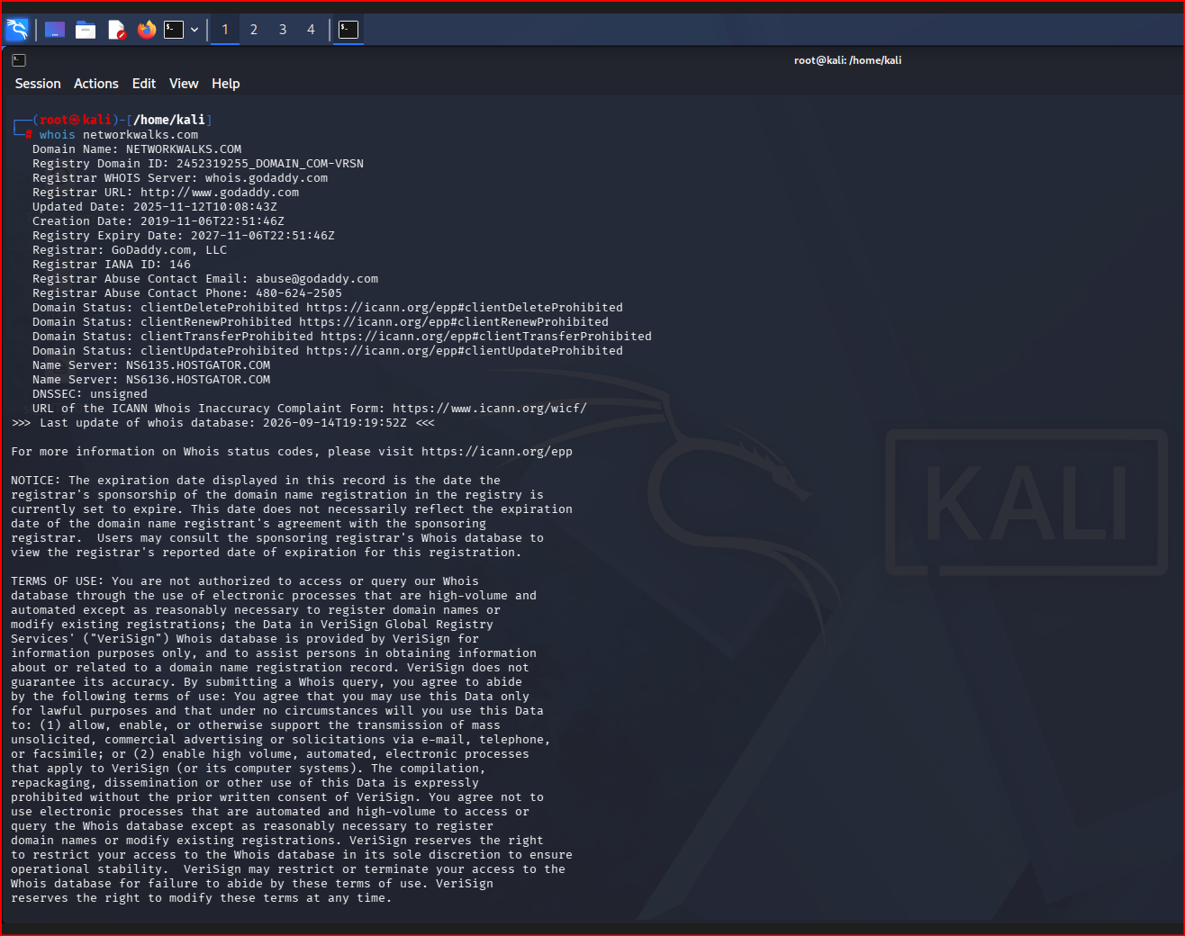

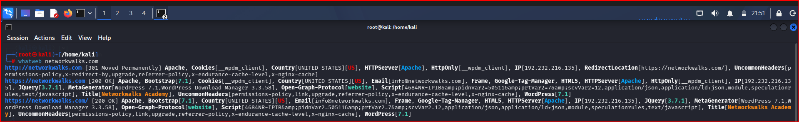

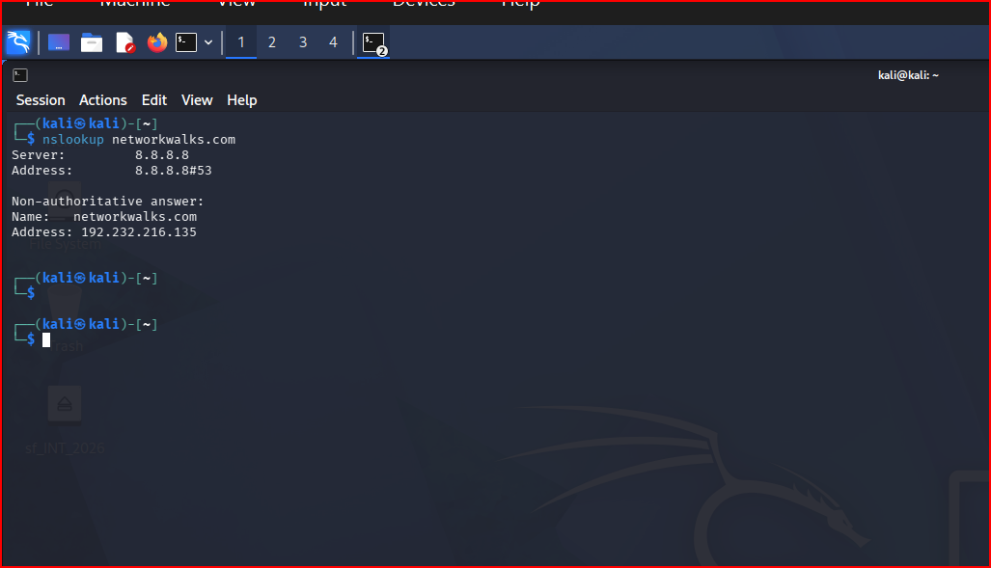

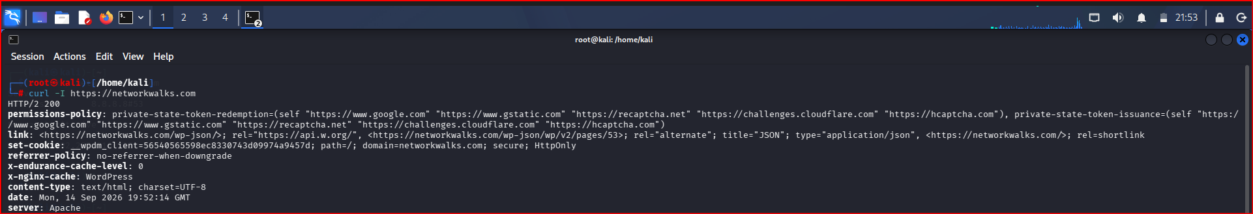

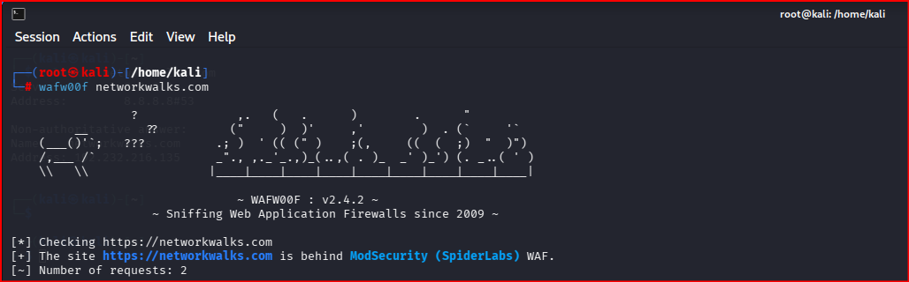
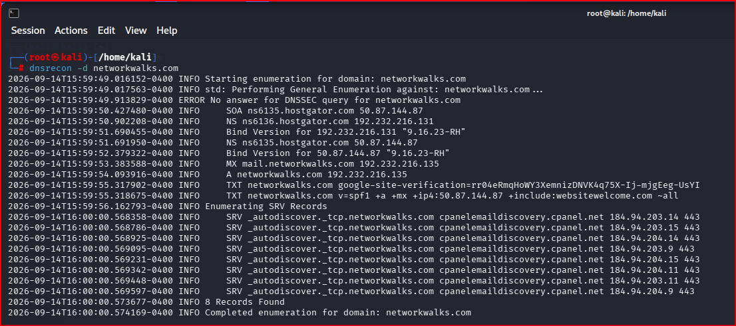

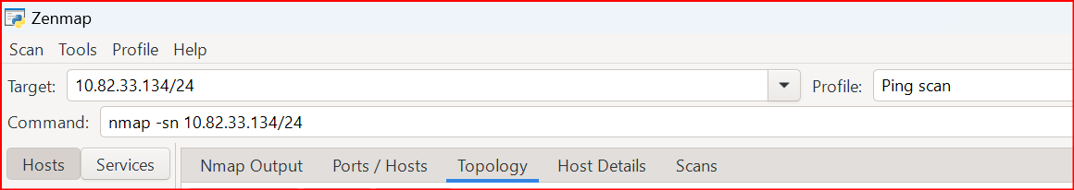

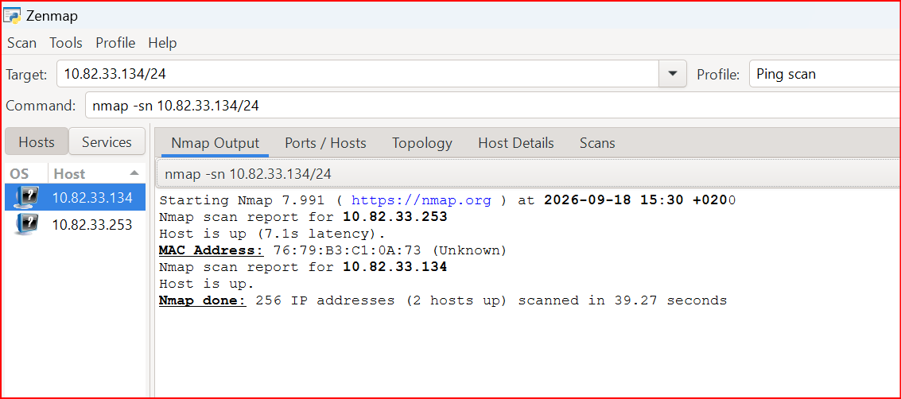
2 Hosts Up
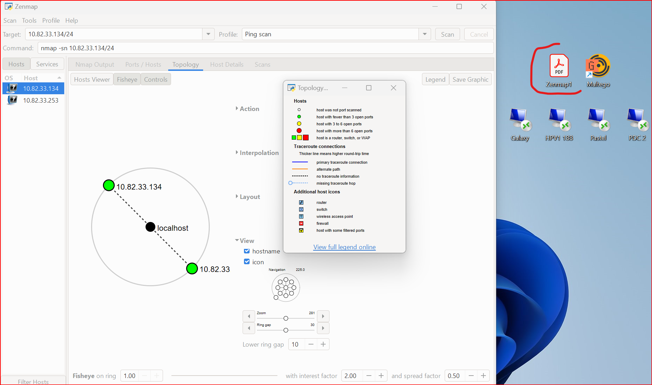

-End-

Author
Rodgers MOONDE
Cybersecurity Professional B083
LinkedIn: https://www.linkedin.com/in/rodgers-moonde/
Project Information
Program Name: Cybersecurity program at Networkwalks | Week: 02 | Repository: GitHub

